LAB-7
7.1) Deletion at start.
CODE:
#include <stdio.h>
#include <stdlib.h>

struct Node {
int data;
struct Node* prev;
struct Node* next;
};

struct Node* head = NULL;

void insert(int data) {
struct Node* newNode = (struct Node*)malloc(sizeof(struct Node));
newNode->data = data;
newNode->next = NULL;
newNode->prev = NULL;

if (head == NULL) {
head = newNode;
return;
}

struct Node* temp = head;
while (temp->next != NULL) {
temp = temp->next;
}

temp->next = newNode;
newNode->prev = temp;
}

void display() {
struct Node* temp = head;

while (temp != NULL) {
printf("%d <-> ", temp->data);
temp = temp->next;
}
printf("NULL\n");
}

void deleteStart() {
if (head == NULL) {
printf("List is empty\n");
return;
}

struct Node* temp = head;
head = head->next;

if (head != NULL) {
head->prev = NULL;
}

free(temp);
}

int main() {

insert(10);
insert(20);
insert(30);
insert(40);
printf("Doubly Linked List before deletion:\n");
display();
deleteStart();
printf("\nDoubly Linked List after deletion at start:\n");
display();

return 0;
}
EXECUTION:
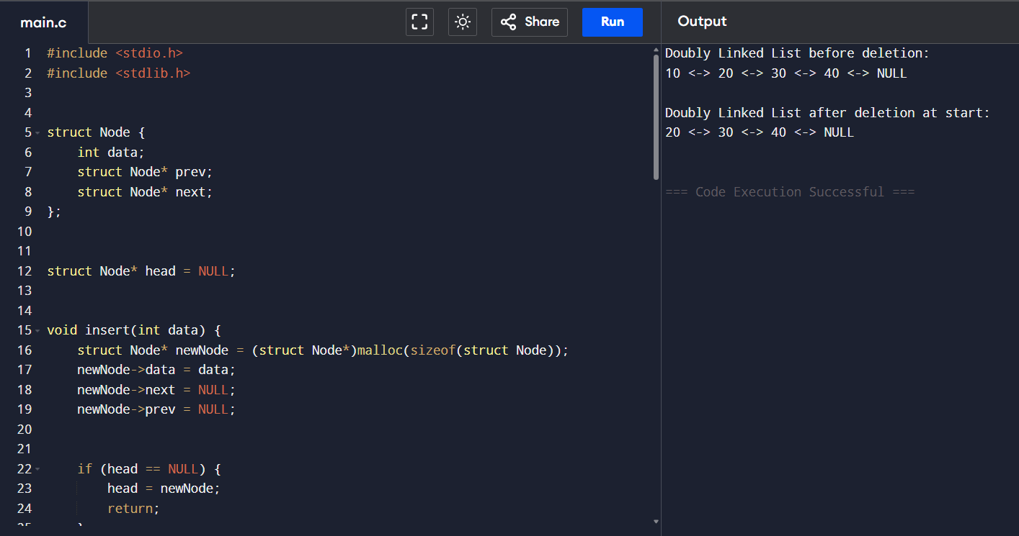

7.2) Deletion at end.
CODE:
#include <stdio.h>
#include <stdlib.h>

struct Node {
int data;
struct Node* prev;
struct Node* next;
};

struct Node* head = NULL;

// Insert node at end (to create list)
void insert(int data) {
struct Node* newNode = (struct Node*)malloc(sizeof(struct Node));
newNode->data = data;
newNode->next = NULL;
newNode->prev = NULL;

if (head == NULL) {
head = newNode;
return;
}

struct Node* temp = head;

while (temp->next != NULL) {
temp = temp->next;
}

temp->next = newNode;
newNode->prev = temp;
}

// Display list
void display() {
struct Node* temp = head;

while (temp != NULL) {
printf("%d <-> ", temp->data);
temp = temp->next;
}

printf("NULL\n");
}

// Delete node at end
void deleteEnd() {

if (head == NULL) {
printf("List is empty\n");
return;
}

struct Node* temp = head;

// Only one node
if (head->next == NULL) {
free(head);
head = NULL;
return;
}

while (temp->next != NULL) {
temp = temp->next;
}

temp->prev->next = NULL;
free(temp);
}

int main() {

insert(10);
insert(20);
insert(30);
insert(40);

printf("Doubly Linked List before deletion:\n");
display();

deleteEnd();

printf("\nDoubly Linked List after deletion at end:\n");
display();

return 0;
}
EXECUTION:
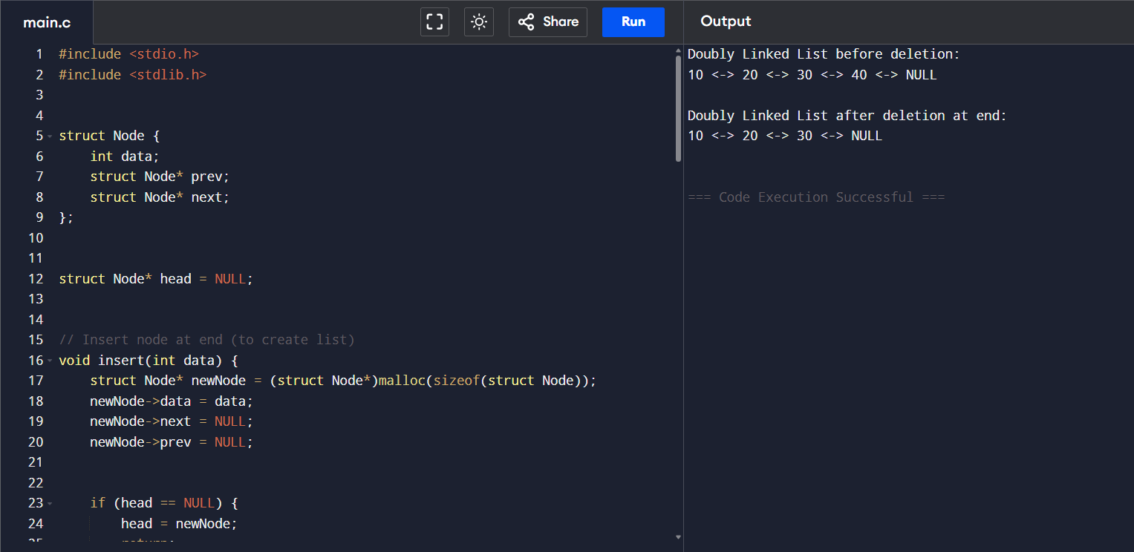
7.3) Deletion at given position.
CODE:
#include <stdio.h>
#include <stdlib.h>

struct Node {
int data;
struct Node* prev;
struct Node* next;
};

struct Node* head = NULL;

// Insert node at end
void insert(int data) {
struct Node* newNode = (struct Node*)malloc(sizeof(struct Node));
newNode->data = data;
newNode->next = NULL;
newNode->prev = NULL;

if (head == NULL) {
head = newNode;
return;
}

struct Node* temp = head;

while (temp->next != NULL) {
temp = temp->next;
}

temp->next = newNode;
newNode->prev = temp;
}

// Display list
void display() {
struct Node* temp = head;

while (temp != NULL) {
printf("%d <-> ", temp->data);
temp = temp->next;
}
printf("NULL\n");
}

// Delete at given position
void deletePosition(int pos) {

struct Node* temp = head;

for (int i = 1; i < pos; i++) {
temp = temp->next;
}

temp->prev->next = temp->next;

if (temp->next != NULL) {
temp->next->prev = temp->prev;
}

free(temp);
}

int main() {

insert(10);
insert(20);
insert(30);
insert(40);
insert(50);

printf("Doubly Linked List before deletion:\n");
display();

deletePosition(3);

printf("\nDoubly Linked List after deleting position 3:\n");
display();

return 0;
}
EXECUTION:
